Brevard Orthopaedic Specialists – Dr. Wade
New Patient/Established New Problem Questionnaire
**Please Fill Out ALL Sections**
Body Part To Be Evaluated TODAY: Date of Injury, if applicable:_____________________________
Foot: □ Right □ Left □ Both Knee: □ Right □ Left □ Both □ Other: ______________________
Ankle: □ Right □ Left □ Both Hip: □ Right □ Left □ Both
How long have you had this pain: __________Days _________Weeks __________ Months ___________ Years
Have you seen another provider for this same problem? □ YES □ NO ; If yes, who: ____________________________
How did you hear about Dr. Wade? ____________________________________________________________________
Do you have a previous injury to this body part in the past? □ NO □ YES= please describe_______________________
__________________________________________________________________________________________________
Have you ever had surgery to this body part in the past? □ NO □ YES= please provide year, type of surgery, name of surgeon, city/state of surgery, if applicable_______________________________________________________________
__________________________________________________________________________________________________
Do you have any of the following: Diabetes- □ YES □ NO / Neuropathy- □ YES □ NO / Gout □ YES □ NO
“Rheumatoid” Arthritis- □ YES □ NO / Osteoporosis(-penia)- □ YES □ NO / Tobacco Use? □ YES □ NO
Infection History of skin or wound? □ YES □ NO If yes, please describe: ______________________________________
__________________________________________________________________________________________________
Is this a Worker’s Compensation Injury: □ YES □ NO ; If yes= Where do you work? ____________________________ Date of Injury: ___________________ Are you working? □ YES □ NO
Do you have a lawyer or are you in litigation for this injury? □ YES □ NO □ N/A
(Females Only): Is there a possibility you may be pregnant? □ YES □ NO
ADDITIONAL NOTES: ________________________________________________________________________________
__________________________________________________________________________________________________
__________________________________________________________________________________________________
__________________________________________________________________________________________________
__________________________________________________________________________________________________
__________________________________________________________________________________________________Continue to next Page ►

Previous XR/CT/MRI? □ NO □ YES: ______________ Previous Injections? □ NO □ YES: ________________
Previous Treatments/Physical Therapy? □ NO □ YES: ____________________________________________
-Please circle ALL that apply in the following section-
Quality of Pain: aching / burning / dull / piercing / sharp / throbbing
Alleviating Factors: rest / ice / heat / elevation / medication / mobility / stretching / shoes / nothing
Aggravating Factors: standing / walking / stair climbing / pushing off / shoes / nothing
Other Associated Symptoms:
Bruising Decreased Mobility Instability Difficulty Going to Sleep Limping Locking
Night Pain Popping/Catching Spasms Numbness/Tingling Swelling Weakness
-Mark the area of the body where the pain is most severe and please circle the severity on the scale-
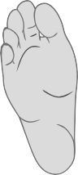
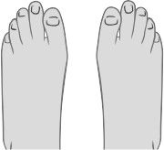
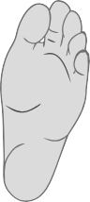
10 = worst and 1 = least pain 1 2 3 4 5 6 7 8 9 10
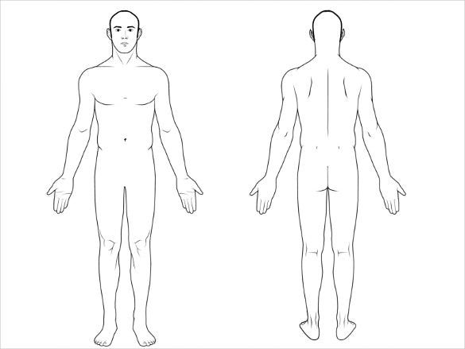

Patient Signature: _________________________________Date: __________
Staff Use Below: ------------------------------------------------------------------------------
Exam:

Assessment: _______________________________________________________________________________________
Plan: OTC Salves Education: _____________________ MRI/CT: __________________________________ Rx Compound
Custom Orthotic Rx Labs: ______________ Injection: ____________________ Prescription: ___________
Surgery Booking Sheet: _______________________________________ PT: ___________________________
Codes: ___________________
_________________________
Outside Imaging: ___________
_________________________
XR Today: ________________
Brace Bootwalker Non-Covered DME: ____________________________________
RTC: __________________________With XR? _____________________________

