Brevard Orthopaedic Specialists – Dr. Wade New Patient/Established New Problem Questionnaire
**Please Fill Out ALL Sections**
How did you hear about Dr. Wade? ____________________________________________________________________
Body Part To Be Evaluated TODAY:
Foot: □ Right □ Left □ Both Knee: □ Right □ Left □ Both □ Other: ______________________
Ankle: □ Right □ Left □ Both Hip: □ Right □ Left □ Both
Quality of Pain (please circle): aching burning stabbing throbbing sharp dull no pain
Date of Injury, if applicable:_____________________________
How long have you had this pain: __________Days _________Weeks __________ Months ___________ Years
-Please circle ALL that apply in the following section-
Alleviating Factors: standing / walking / rest / ice / heat / elevation / medication / stretching / shoes / nothing
Aggravating Factors: sitting / standing / walking / bearing weight / exercise / stair climbing / shoes / nothing
Other Associated Symptoms:
Weakness Numbness/Tingling Swelling Redness Bruising Catching/Locking
Popping/Clicking Instability Limping Night Pain Spasms
--------------------------------------------------------------------------------------------------------------------------------------------------
Have you seen another provider for this same problem? □ YES □ NO ; If yes, who: ____________________________
Do you have a previous injury to this body part in the past? □ NO □ YES= please describe_______________________
__________________________________________________________________________________________________
Have you ever had surgery to this body part in the past? □ NO □ YES= please provide year, type of surgery, name of surgeon, city/state of surgery, if applicable_______________________________________________________________
__________________________________________________________________________________________________
Do you have any of the following: Diabetes- □ YES □ NO / Neuropathy- □ YES □ NO / Gout □ YES □ NO
“Rheumatoid” Arthritis- □ YES □ NO / Osteoporosis(-penia)- □ YES □ NO / Tobacco Use? □ YES □ NO
Infection History of skin or wound? □ YES □ NO If yes, please describe: ______________________________________
__________________________________________________________________________________________________
Continue to next Page ►
Is this a Worker’s Compensation Injury: □ YES □ NO ; If yes= Where do you work? ____________________________ Date of Injury: ___________________ Are you working? □ YES □ NO
Do you have a lawyer or are you in litigation for this injury? □ YES □ NO □ N/A
Previous XR/CT/MRI? □ NO □ YES: ______________ Previous Injections? □ NO □ YES: ________________
Previous Treatments/Physical Therapy? □ NO □ YES: ____________________________________________
-Mark the area of the body where the pain is most severe and please circle the severity on the scale-
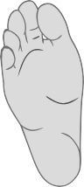
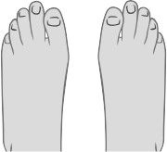
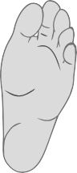
10 = worst and 1 = least pain 1 2 3 4 5 6 7 8 9 10
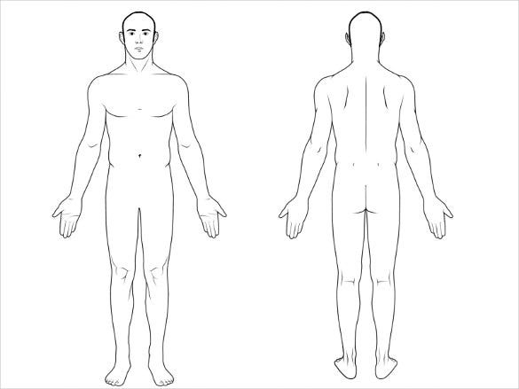

Patient Signature: _________________________________Date: __________

Staff Use Below: -----------------------------------------------------------------------------------------------------------------------------------------
Exam:

Assessment: _______________________________________________________________________________________
Plan: OTC Salves Education: _____________________ MRI/CT: __________________________________ Rx Compound
Custom Orthotic Rx Labs: ______________ Injection: ____________________ Prescription: ___________
Surgery Booking Sheet: _______________________________________ PT: ___________________________
Codes: ___________________
_________________________
Outside Imaging: ___________
_________________________
XR Today: ________________
Brace Bootwalker Non-Covered DME: ____________________________________
RTC: __________________________With XR? _____________________________

Patient Health History Information
**Please fill out completely**
Primary Care Physician:____________________________________________________________________________
Please list name(s) and specialty of any other providers you see (i.e. Cardiologist, Rheumatologist, etc):
_________________________________________________________________________________________________
_________________________________________________________________________________________________
Preferred Pharmacy (Name and Location): ______________________________________________________________
_________________________________________________________________________________________________
Are You in Pain Management: □ no □ yes (Who is your provider: ___________________________________________)
Height: _____ft_____in Weight: ___________lbs Pain Scale 0 1 2 3 4 5 6 7 8 9 10
Allergies (Medications and other i.e. latex, nickel, topicals, etc.): ______ See Attached
________________________________________ _______________________________________________
________________________________________ _______________________________________________
________________________________________ _______________________________________________
________________________________________ _______________________________________________
Medications: ____ See Attached
________________________________________ _______________________________________________
________________________________________ _______________________________________________
________________________________________ _______________________________________________
________________________________________ _______________________________________________
________________________________________ _______________________________________________
________________________________________ _______________________________________________
________________________________________ _______________________________________________
Family History (Please list all known family members and what diseases and conditions that apply)
________________________________________ _______________________________________________
________________________________________ _______________________________________________
Social History
Smoking: □ Never Smoker □ Former Smoker (how long did you smoke ______yrs)
□ Current Every Day Smoker □ Current Some Day Smoker (how long have been smoking ____yrs)
(If applicable) How much do you smoke regularly(circle) : 1 PPW 2PPW ¼ PPD ½ PPD 1PPD 2PPD+
Smokeless Tobacco: □ Never □ Former □ Current E-Cigarette/Vape: □ Never □ Former □ Current
Occupation:___________________________________ Employer: _________________________________________
Current Work Status? □ full duty □ part time □ light/limited duty □disabled
Alcohol Consumption: □ none □yes (how much, please circle: none occasional moderate heavy)
History of Drug Abuse? □ no □ yes (type(s) of drug used: ______________________________________________
Surgical History (Please provide all information you know, including dates, physicians, locations, etc)
□ None
□ Ankle/Foot: ______________________________________________________________________________________
□ Knee: ___________________________________________________________________________________________
□ Hip: _____________________________________________________________________________________________
□ Shoulder: ________________________________________________________________________________________
□ Elbow/Hand: _____________________________________________________________________________________
□ Spine: ___________________________________________________________________________________________
□ Heart: ___________________________________________________________________________________________
□ Other: ___________________________________________________________________________________________
Have you ever had a complication with being under anesthesia? □ no □ yes
If yes, please explain:________________________________________________________________________________

Past Medical History
□ None
□Alzheimer’s/Dementia □ Glaucoma
□ Anemia □ Gout
□ Aneurysm □ Heart Disease/Heart Attack
□ Anxiety Disorder/Depression □ Hepatitis, HIV or AIDS
□ Arrythmia or Atrial Fibrillation □ High Cholesterol
□ Asthma □ High Blood Pressure
□ Autoimmune Disorder □ Kidney Problems
□ Bleeding Disorder □ Liver Problems
□ Blood Clot (DVT, Pulmonary Embolism) □ Migraines
□ Blood Transfusion □ Multiple Sclerosis
□ Brain Tumor □ Neuropathy
□ COPD □ Osteoporosis
□ Cancer □ Pacemaker
□ Cerebral Palsy □ Peripheral Vascular Disease
□ Coronary Artery Disease □ Prior/Current MRSA/Staph Infection
□ Dementia □ Rheumatoid Arthritis
□ Diabetes type I/II □ Sleep Apnea
□ Have you had an Echocardiogram? □ Stomach Ulcers
□ Have you had an Electrocardiogram/ECG? □ Stroke
□ Fibromyalgia □ Thyroid Disorder
If yes to any above or need to add, please explain: _________________________________________________________
(Females Only): Is there a possibility you may be pregnant? □ YES □ NO
Have you tested positive or been exposed to COVID? □ YES □ NO; If yes, were you retested negative? □ YES □ NO
Have you Received any COVID vaccines? □ YES □ NO

